XML

- XML stands for extensible markup language
- XML is mainly used to transport and store data
- XML is case sensitive
- XML is strict. All open tags should have matching closing tags
- XML is platform independent
- Must have a single root
- Quotes mandatory for attributes

Ex:
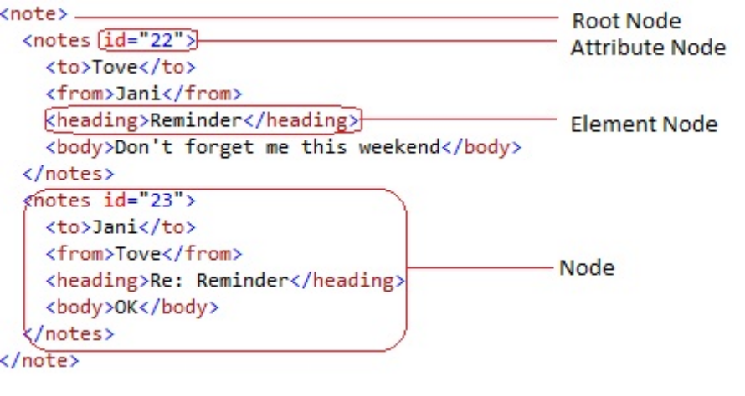
Elements vs Attributes
It is preferable to use elements, rather than attributes. Actual practice is to use elements for the actual data and meta data is included in attributes.

Problems with attribute usage:
•attributes cannot contain multiple values (child elements can)
•attributes are not easily expandable (for future changes)
•attributes cannot describe structures (child elements can)
•attributes are more difficult to manipulate by program code
•attribute values are not easy to test against a DTD

Illegal Characters in XML and their valid counter parts:

< | &lt;
> | &gt;
& | &amp;
“ | &quot;

XML namespaces:
XML Namespaces provide a method to avoid element name conflicts and define the scope of the elements and attributes in use. These are defined by the xmlns attribute in the start tag of an element. For differentiating between multiple namespaces in a single element, prefixes are used.

Syntax: xmlns:prefix="URI"

Why namespaces:
Element names are defined by the designers and may conflict with names used by XMLs in other domains and applications. This can create issues when these XMLs are mixed together.
Ex: <furniture>
<table></table>
</furniture>
<table>
<tr />
</table>

<Products xmlns="http://Products" xmlns:Movie="http://Products/Movie" xmlns:Game="http://Products/Game">
<Movie:Product>Movie1</Movie:Product>
<Movie:Product>Movie2</Movie:Product>
<Game:Product>Game1</Game:Product>
<Game:Product>Game2</Game:Product>
</Products>

DTD
A Document Type Definition (DTD) defines the legal building blocks of an XML document. It defines the document structure with a list of legal elements and attributes. It is used to communicate and validate the XML structure.

Ex:
<!DOCTYPE NEWSPAPER [
<!ELEMENT NEWSPAPER (ARTICLE+)>
<!ELEMENT ARTICLE (HEADLINE,BYLINE,LEAD,BODY,NOTES)>
<!ELEMENT HEADLINE (#PCDATA)>
<!ELEMENT BYLINE (#PCDATA)>
<!ELEMENT LEAD (#PCDATA)>
<!ELEMENT BODY (#PCDATA)>
<!ELEMENT NOTES (#PCDATA)>
<!ATTLIST ARTICLE AUTHOR CDATA #REQUIRED>
<!ATTLIST ARTICLE EDITOR CDATA #IMPLIED>
<!ATTLIST ARTICLE DATE CDATA #IMPLIED>
<!ATTLIST ARTICLE EDITION CDATA #IMPLIED>
]>

Sample XML for the above DTD:
<NEWSPAPER>
<ARTICLE AUTHOR="" EDITOR="" DATE="" EDITION="">
<HEADLINE></HEADLINE>
<BYLINE></BYLINE>
<LEAD></LEAD>
<BODY></BODY>
<NOTES></NOTES>
</ARTICLE>
<ARTICLE AUTHOR="">
<HEADLINE></HEADLINE>
<BYLINE></BYLINE>
<LEAD></LEAD>
<BODY></BODY>
<NOTES></NOTES>
</ARTICLE>
</NEWSPAPER>

PCDATA - Parsed Character Data
XML parsers normally parse all the text in an XML document.When an XML element is parsed, the text between the XML tags is also parsed.
Ex: <message>This text is also parsed</message>
This is done because a XML element can contain other elements and those have to be parsed as well.
Ex: <name><first>Bill</first><last>Gates</last></name>

Here, the name element contains two other elements – first and last. The parser breaks the current element down into its child nodes as shown below:
<name>
<first>Bill</first>
<last>Gates</last>
</name>

CDATA - (Unparsed) Character Data
The term CDATA is used for text data that should not be parsed by the XML parser. Characters like "<" and "&" are illegal in XML elements.
"<" will generate an error because the parser interprets it as the start of a new element.
"&" will generate an error because the parser interprets it as the start of an character entity.
To avoid such errors the text can be defined as CDATA. Everything inside a CDATA section is ignored by the parser.

Rules for CDATA section:
- A CDATA section starts with "<![CDATA[" and ends with "]]>"
- A CDATA section cannot contain the string "]]>"
- Nested CDATA sections are not allowed
- The "]]>" that marks the end of the CDATA section cannot contain spaces or line breaks

Ex:
<script>
<![CDATA[
function matchwo(a,b)
{
if (a < b && a < 0) then
{
return 1;
}
else
{
return 0;
}
}
]]>
</script>

Internal DTD definition:
<?xml version="1.0"?>
<!DOCTYPE note [
<!ELEMENT note (to,from,heading,body)>
<!ELEMENT to (#PCDATA)>
<!ELEMENT from (#PCDATA)>
<!ELEMENT heading (#PCDATA)>
<!ELEMENT body (#PCDATA)>
]>
<note>
<to>Tove</to>
<from>Jani</from>
<heading>Reminder</heading>
<body>Don't forget me this weekend</body>
</note>

External DTD definition:
<?xml version="1.0"?>
<!DOCTYPE note SYSTEM "note.dtd">
<note>
<to>Tove</to>
<from>Jani</from>
<heading>Reminder</heading>
<body>Don't forget me this weekend!</body>
</note>

Entity Declaration:
An entity has three parts: an ampersand (&), an entity name, and a semicolon (;).
Syntax: <!ENTITY entity-name "entity-value">

Ex:
<!ENTITY writer "John Smith">
<!ENTITY copyright "Copyright Saggezza">
Usage: <author>&writer;&copyright;</author>

External Entity Declaration:
<!ENTITY entity-name SYSTEM "URI/URL">

Ex:
<!ENTITY writer SYSTEM "http://test/entities.dtd">
<!ENTITY copyright SYSTEM "http://test/entities.dtd">
Usage: <author>&writer;&copyright;</author>

XML Schemas
XML Schema is an XML-based alternative to DTD. An XML schema describes the structure of an XML document. XML Schemas are the Successors of DTDs. The XML Schema language is also referred to as XML Schema Definition (XSD).

Advantages over DTD:
•XML Schemas are extensible to future additions
•XML Schemas are richer and more powerful than DTDs
•XML Schemas are written in XML
•XML Schemas support data types
•XML Schemas support namespaces

Why XML Schemas:
•defines elements that can appear in a document
•defines attributes that can appear in a document
•defines which elements are child elements
•defines the order of child elements
•defines the number of child elements
•defines whether an element is empty or can include text
•defines data types for elements and attributes
•defines default and fixed values for elements and attributes

XSD Data types:
•xs:string
•xs:decimal
•xs:integer
•xs:boolean
•xs:date
•xs:time

Ex:
<NEWSPAPER xmlns="http://www.saggezza.com/article">
<ARTICLE AUTHOR="" EDITOR="" DATE="" EDITION="">
<HEADLINE></HEADLINE>
<BYLINE></BYLINE>
<LEAD></LEAD>
<BODY></BODY>
<NOTES></NOTES>
</ARTICLE>
<ARTICLE AUTHOR="">
<HEADLINE></HEADLINE>
<BYLINE></BYLINE>
<LEAD></LEAD>
<BODY></BODY>
<NOTES></NOTES>
</ARTICLE>
</NEWSPAPER>

<?xml version="1.0" encoding="utf-8"?>
<xs:schema attributeFormDefault="unqualified" elementFormDefault="qualified" targetNamespace="http://www.saggezza.com/article" xmlns:xs="http://www.w3.org/2001/XMLSchema">
<xs:element name="NEWSPAPER">
<xs:complexType>
<xs:sequence>
<xs:element maxOccurs="unbounded" name="ARTICLE">
<xs:complexType>
<xs:sequence>
<xs:element name="HEADLINE" minOccurs="1" maxOccurs="1"/>
<xs:element name="BYLINE" maxOccurs="1"/>
<xs:element name="LEAD" maxOccurs="1"/>
<xs:element name="BODY" maxOccurs="1"/>
<xs:element name="NOTES" minOccurs="0" maxOccurs="unbounded"/>
</xs:sequence>
<xs:attribute name="AUTHOR" type="xs:string" use="required" />
<xs:attribute name="EDITOR" type="xs:string" use="optional" />
<xs:attribute name="DATE" type="xs:string" use="optional" />
<xs:attribute name="EDITION" type="xs:string" use="optional" />
</xs:complexType>
</xs:element>
</xs:sequence>
</xs:complexType>
</xs:element>
</xs:schema>

Xpath
XPath is used to navigate through elements and attributes in an XML document. It is similar to file traversal in a file system.

Comparison (File system vs XPath):
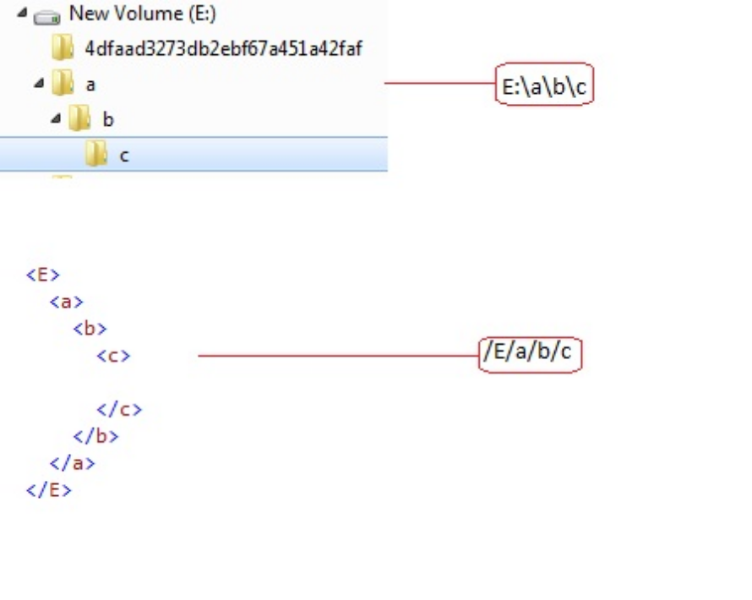

Xpaths Symbols:
<nodeName> | Selects Child nodes with”nodeName”
/ | Selects a node relative to the root node
// | Select from the entire document
. | Select the current node
.. | Select the parent of the current node
@ | Select attribute

Xpath Axes:
An axis defines a node-set relative to the current node

Syntax: axisname::node[predicate]
Ex: ancestor-or-self::book
child::*/child::price

Axis | Description
ancestor | Selects all ancestors of the current node
ancestor-or-self | Selects all ancestors of the current node and the current node itself
attribute | Selects all attributes of the current node
child | Selects all children of the current node
descendant | Selects all descendants of the current node
descendant-or-self | Selects all descendants of the current node and the current node itself
following | Selects everything in the document after the closing tag of the current node
following-sibling | Selects all siblings after the current node
namespace | Selects all namespace nodes of the current node
parent | Selects the parent of the current node
preceding | Selects all nodes that appear before the current node in the document, except ancestors, attribute nodes and namespace nodes
preceding-sibling | Selects all siblings before the current node
self | Selects the current node

Xpath with namespaces:
<?xml version="1.0" encoding="ISO-8859-1"?>
<a xmlns="test1" xmlns:b="test">
<b:movi format="DVD">hello1</b:movi>
<b:movi format="DVD">hello2</b:movi>
<b:movi format="Blu-Ray"></b:movi>
<Game>test1</Game>
<Game>test2</Game>
</a>

Ex:
With implied namespace prefix:
/:a/:Game | /:a/b:movi[@format='DVD']
/test:a/test:Game | /test:a/b:movi[@format='DVD']

Without implied namespace prefix:
/*[local-name()='a' and namespace-uri()='test1']/*[local-name()='Game' and namespace-uri()='test1'] | /*[local-name()='a' and namespace-uri()='test1']/b:movi[@format='DVD']

XSLT
XSL stands for Extensible Stylesheet Language, and is a style sheet language for XML documents.XSLT stands for XSL Transformations. It is used to transform a XML into another format. It is considered under the templating or functional paradigm. It uses pure functions and immutable variables. It uses XML syntax and hence strict XML rules apply.

Ex:
XML:
<?xml version="1.0" encoding="ISO-8859-1"?>
<a>
<movi format="DVD">hello1</movi>
<movi format="DVD">hello2</movi>
<movi format="Blu-Ray">hello3</movi>
<Game>test1</Game>
<Game>test2</Game>
</a>

XSL:
<?xml version="1.0"?>
<xsl:stylesheet version="1.0"
xmlns:xsl="http://www.w3.org/1999/XSL/Transform">
<xsl:template match="/">
<html>
<body>
<h2>Product Collection</h2>
<table>
<tr>
<th>Title</th>
</tr>
<xsl:for-each select="*">
<tr>
<td><xsl:value-of select="."/></td>
</tr>
</xsl:for-each>
</table>
</body>
</html>
</xsl:template>
</xsl:stylesheet>

Output:
<html>
<body>
<h2>Product Collection</h2>
<table>
<tr>
<th>Title</th>
</tr>
<tr>
<td>hello1</td>
</tr>
<tr>
<td>hello2</td>
</tr>
<tr>
<td>hello3</td>
</tr>
<tr>
<td>test1</td>
</tr>
<tr>
<td>test2</td>
</tr>
</table>
</body>
</html>

